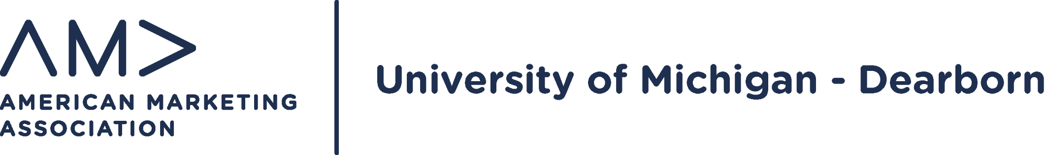

AMA Fall 2021 Executive Board Application
- For your convenience, this form can be completed digitally within Microsoft Word. After you convert the document to Word, place your cursor inside the various form areas and begin typing.
- In the “Select Positions of Interest” section, you can highlight the positions you’re interested in applying for.
- After you have completed the form and the associated questions on the next page, please save it in the following format: AMA UMD Fall 2021 E-Board Application_FullName (preferred format is a PDF file).
- Send your file to the president, Alex Jacobson (alexcjac@umich.edu) with the subject matching the same format of the PDF file mentioned above. Although it is not required, you may attach your most current resume.
- Note: Deadline to submit your application is Friday, May 21st, 2021.
Thank you for applying and good luck! :)

Applicant Information
Full Name:
 | Last | First | M.I.
E-mail:
 | Please provide your UMICH email
 | City | State | ZIP Code
Phone:

Select Positions of Interest
Of the positions listed below, please select (highlight) 2-3 positions you would be most interested in being considered for candidacy.

AMA UM-D Open Vice President (VP) Positions
VP of Recruitment | VP of Competitions | VP of Communications
VP of Prof Development | VP of Advertising

AMA UMD Open Director Positions

Director of Competitions | Director of Advertising
Director of Prof Development

Please answer the following questions:

- Briefly explain your current career goals and why? (e.g. I want to do PR, etc.)

- Why did you pick the position choices above? (Please note which position is your top choice)

- What is something you would like to implement or what improvements would you like to see AMA incorporate for the Winter semester?

- What suggestions/ideas do you have of ways to make AMA more interactive for students in the virtual environment?

